## Getting Started with Azure and Office 365 Development

**Lab Time**: 45 minutes

**Lab Folder**: C:\Student\Modules\01_GettingStarted\Lab

**Lab Overview**: In this lab you will get up and running with the Cloud Client VM created by Critical Path Training. You will log onto the VM and make sure you are able to use the developer tools such as launching Visual Studio 2015. You will also perform the necessary tasks of create an Office 365 trial account which will create an Office 365 tenancy that you will use for your development environment. Once you have created your Office 365 tenancy, you will then install the Office 2016 client applications on your development workstation. In the last exercise, you will either work with your existing Microsoft Azure subscription or create a new trial subscription in Microsoft Azure that you will use in lab exercises.

### Exercise 1: Getting Up and Running with the Student VM

In this exercise will you begin by logging into your copy of the Cloud Client VM from Critical Path Training. Once you have successfully logged into the VM, you will verify that the VM has a reliable connection to the Internet.

1. Login to the Student VM using the login **Student** and a password will be **Password1**.

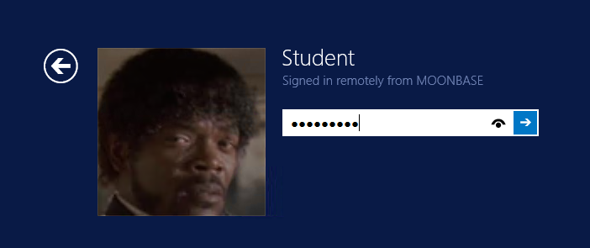

Note that the VM is based on a simple installation of Windows 10 which runs standalone without a domain. The **Student** account is a local account on the VM which has been configured with administrator privileges. If you would rather connect to the VM using a remote desktop connection instead of the Hyper-V console, you might need to use an account name of **localacount\Student** instead of **Student**.

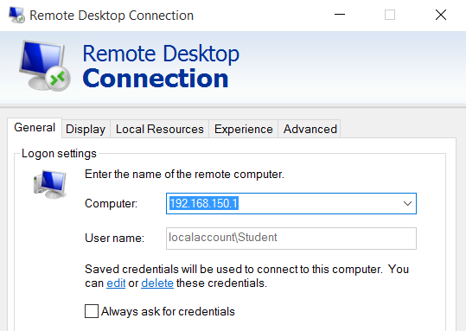

1. Once you have logged on to the student VM, launch the Internet Explorer or Chrome and navigate to a familiar site on the Internet such as <http://bing.com> or <http://google.com>. The purpose of this step is to ensure you have a reliable Internet connection. Once you validate that your copy of the VM can connect to the Internet, you can move onto the next exercise.

If a browser on your student VM cannot connect to the Internet, you must troubleshoot this issue and correct it before moving on.

### Exercise 2: Create an Office 365 Trial Account

In this exercise, you will create a new Office 365 tenant which allows you to create up to 25 user accounts with Enterprise E5 trial licenses. Note that the Enterprise E5 trial license provides the benefits of the Office 365, SharePoint Online and Power BI Pro. Being able to create multiple Office 365 user accounts in your cloud-based testing environment will be important so that you can test the effects working with multiple users.

1. Navigate to the following URL:

<https://go.microsoft.com/fwlink/p/?LinkID=698279&culture=en-US&country=US>

1. Fill out the form with your personal information and click **Next**.

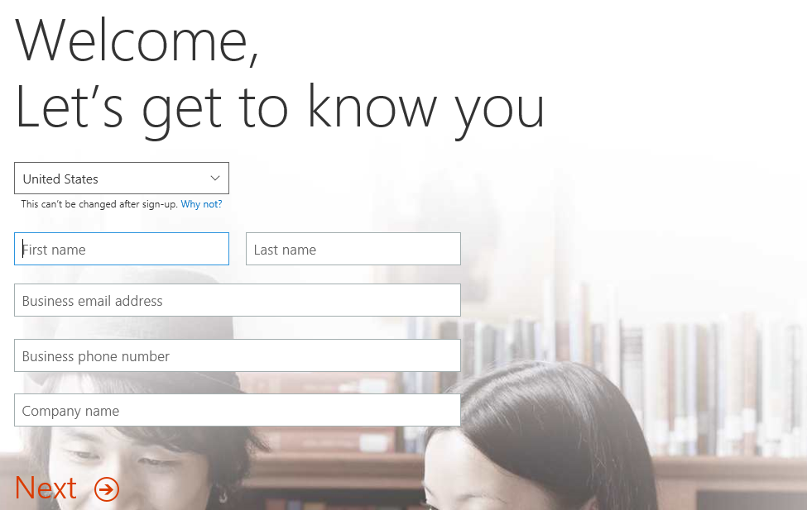

The information you provide here will be used throughout your tenant so if you do not wish to use your actual company name then provide humorous and fictitious company name. The name you use for company name will turn out to be the name of the trial Office 365 tenant that you are creating.

1. On the next page, you are prompted to provide a user ID, company name and password.

Note that the company name you enter on this page will be used to create the domain name for your new Office 365 trial tenant. For example, if you were to enter a company name of **CBD365**, it would result in the creation of a new Office 365 tenant within a domain of **CBD365.onMicrosoft.com**. The user name you enter will be used to create the first user account which will be given administrative rights within the trial tenant. If you enter a user name of **Student**, then the email address as well as user principal name for this account will be **Student@CBD365.onMicrosoft.com**.

1. Enter a user name and a company name for your new Office 365 trial tenant. For the company name, you may wish to simply use your first and/or last name with a number which you can increment each time you have to create a new trial account (e.g. EricClapton1.onmicrosoft.com).

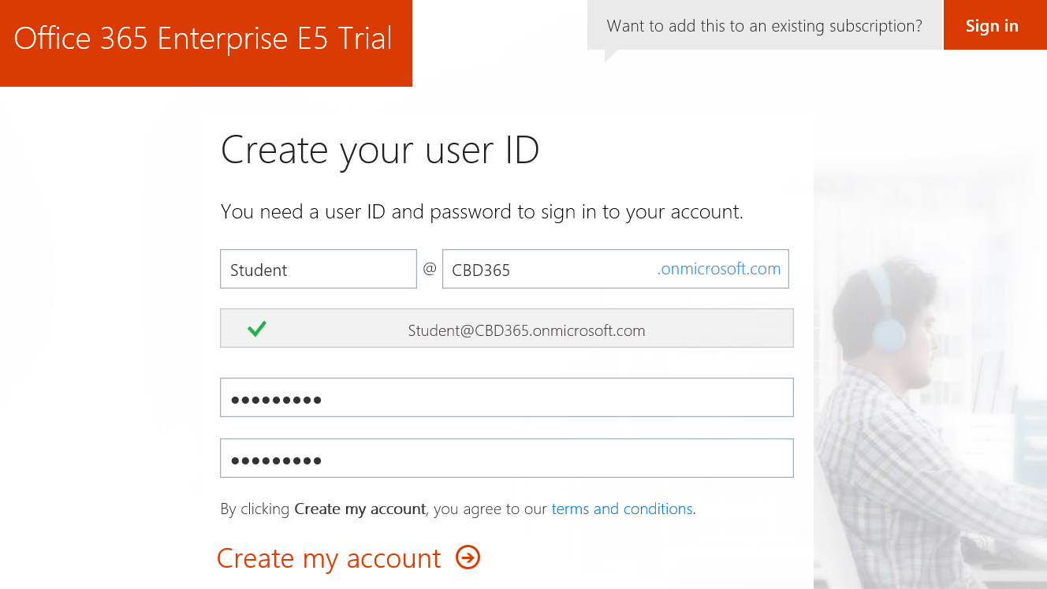

Don’t use your actual company name as that may cause some conflict when your company decides to create their own official tenant. Throughout the remainder of this guide you will see a company domain name of **CBD365** which you should replace with the value specified for your company name.

1. Click **Next** to continue to step 3.
2. Complete the validation form in step 3 by proving you are not a robot.
   1. Select the **Text me** option and provide the number of your mobile phone.
   2. When you go through this process, a Microsoft service will send you a text message that contains an access code.
   3. You retrieve the access code form your mobile device and use it to complete the validation process.



1. Once you have completed the validation process, click the **You’re ready to go…** link to navigate to the portal welcome page for your new Office 365 trial tenant. Note that you should already be logged on using the user account that was created during the sign up process.

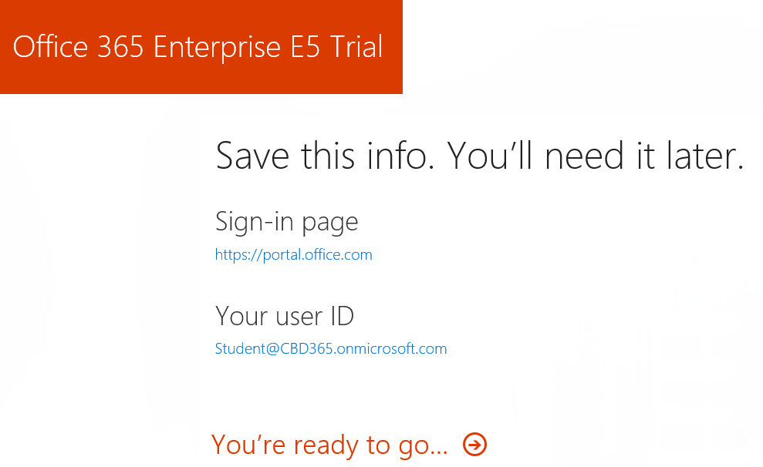

At this point, you have already created your new Office 365 tenant which can support creating up to 25 user accounts with Office 365 Enterprise E5 trial licenses. Note that some Office 365 services within your new Office 365 tenant such as the Office 365 admin center can be accessed immediately. Other services within your Office 365 tenant such as SharePoint Online are not ready immediately and will take some time to provision.

1. You should now be located on the portal welcome page of the Office 365 portal. You will notice that this page shows the progress of the Office 365 environment in provisioning each of the individual services that make up your new Office 365 trial tenant. Click the **Admin** tile to proceed to the Office **365 admin center**.

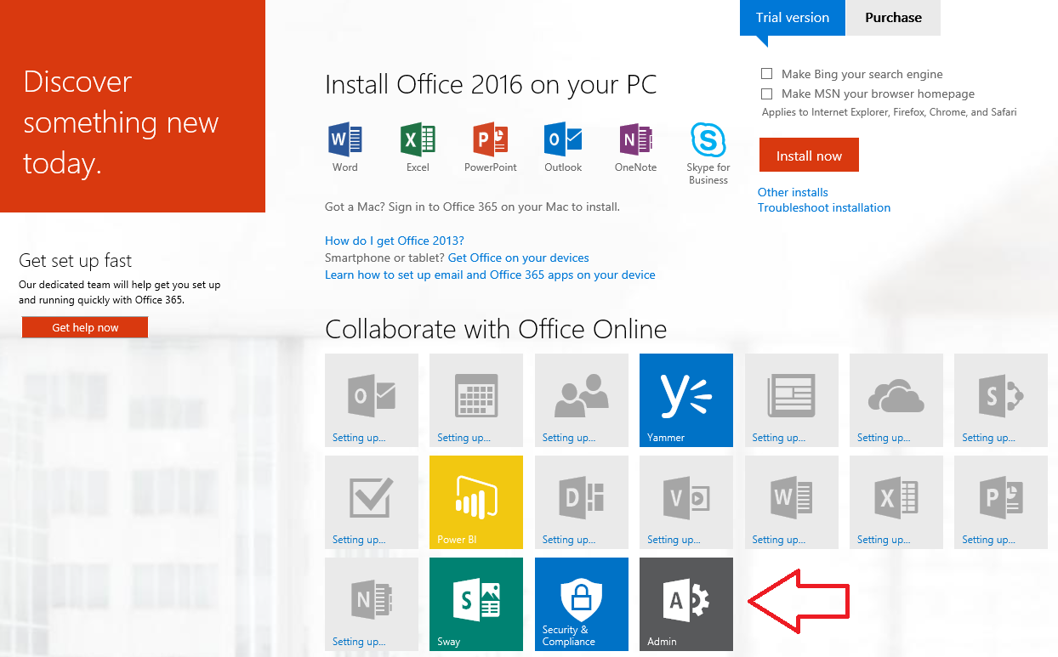

In of April 2016, Office 365 introduced a new user interface experience of the Office 365 admin center which is currently in preview. While it will be possible for you to fall back on the older UI experience for the Office 365 Admin center, we assume you will use the new preview edition so that is what we will show in the screenshots for this lab.

1. If you are presented with the Office 365 admin center welcome dialog, close it by clicking the **X** menu in the upper right corner.

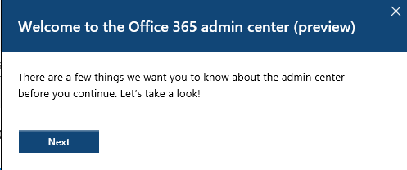

1. Verify that you are able to access the home page of the **Office 365 admin** **center**.
   1. The following screenshot shows what the Office 365 Admin center looks like as of April 2016 with the introduction of the new user interface experience.

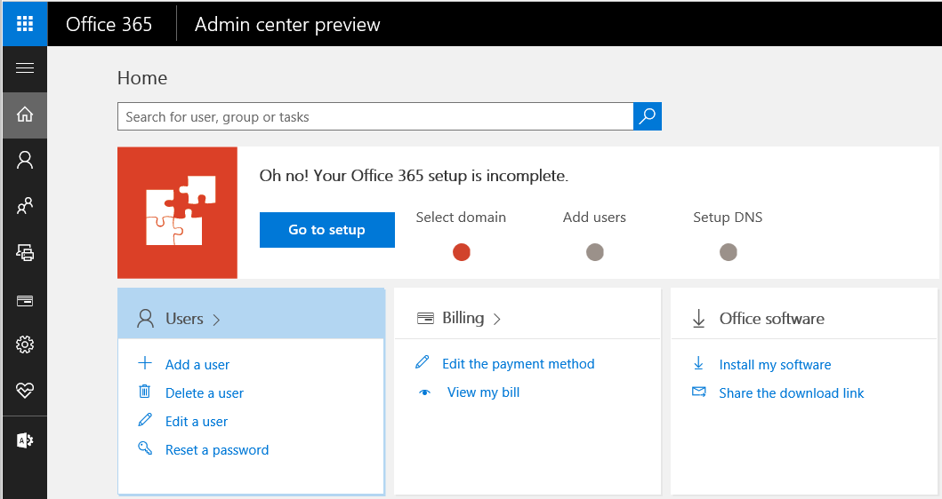

* 1. Locate the top **Menu** button for the left navigation menu. It’s the second button from the top which sites just beneath the Office 365 App Launcher menu button.

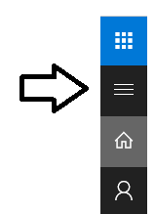

* 1. Click the top **Menu** button several times and see how it toggles the left navigation between a collapsed and expanded mode.

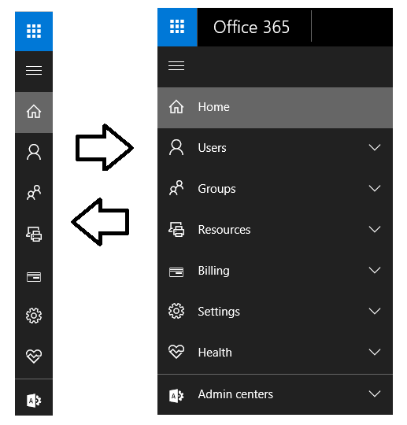

If you are interested in getting more familiar with the **Office 365 admin center**, take a minute to explore the administrative pages behind the left navigation menu in the Office 365 admin center.

1. Install the Office 2016 client applications.
   1. Locate and click on the **Install my software** link on the home page of Office 365 admin center.

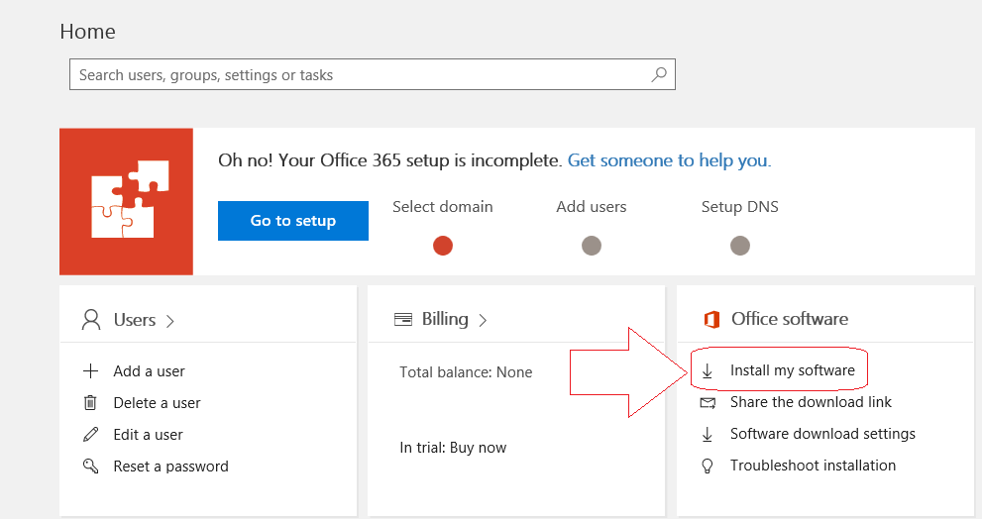

* 1. You should now be at the **Office** tab of the **Software** page. Locate and click the **Advanced** link to set the installation option to install the 64-bit version of Office 2016 instead of the 32-bit version.

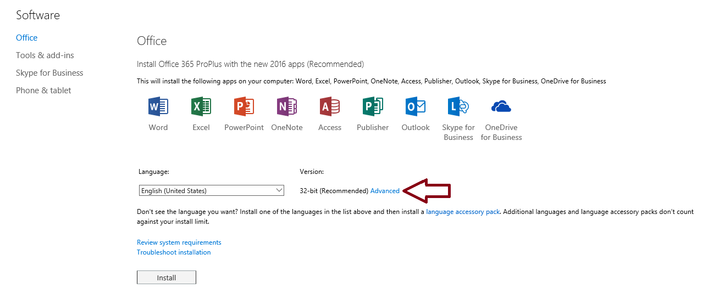

* 1. Use the dropdown menu to change the Version setting to **64 bit**. And then click the install button to begin the installation.

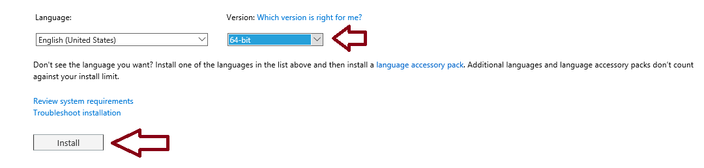

* 1. Follow the instructions to install Office 2016.
  2. Once the installation is complete, return to the Office 365 admin center at <https://portal.office.com/AdminPortal/Home>.

1. Make sure you can access your Office 365 inbox to read and send messages.
   1. Click on the Office 365 App Launcher menu button in the top-left corner of the page.



* 1. Click the **Mail** tile button in the App Launcher menu to navigate to Outlook Web Access (OWA).

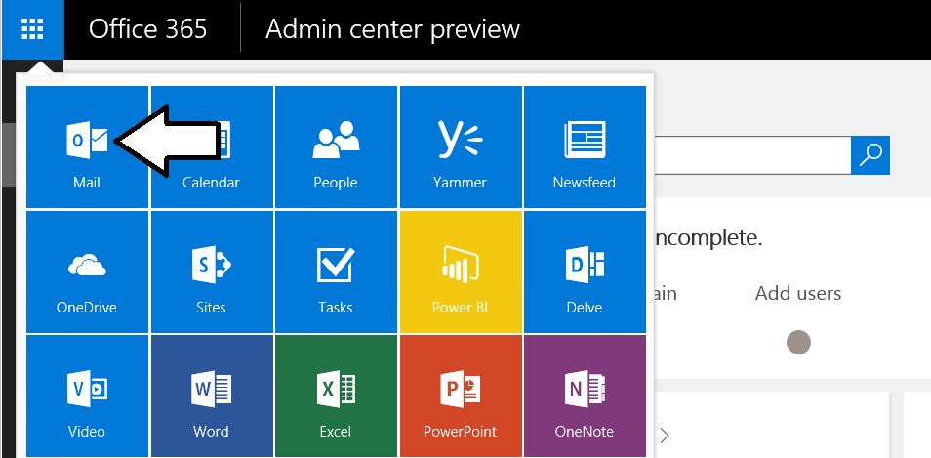

* 1. If prompted, specify your language and time zone for Outlook.



* 1. You should now see a web page with the Office 365 Outlook web access client and a view the Exchange inbox that is associated with the primary user account that was created when you created the Office 365 tenancy.

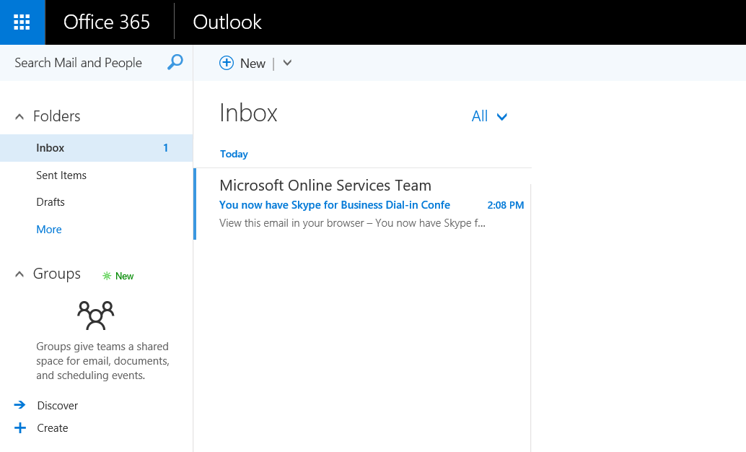

* 1. Test email by sending a message to one of your other email addresses, Display the form to create a new email clicking the **New** button. If the **New** button is not showing, it’s probably because the form to create a new email is already showing.

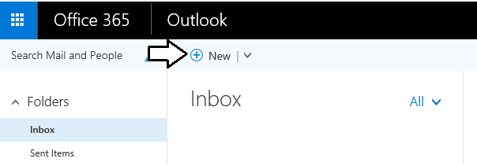

* 1. At this point, you should see the Outlook form to create new email on the right side of the page.

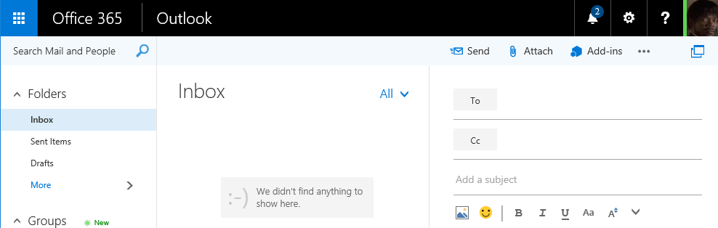

* 1. Fill out the new email form using sample data (see example below) to send a test message. Be sure to send the test message to an email address that is yours. Click **Send** when it’s ready to go.

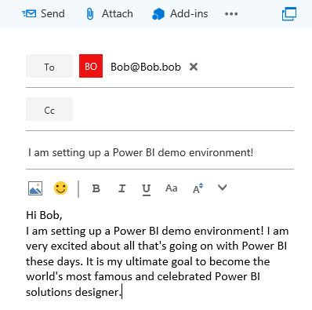

* 1. Click **Send** to send the email.
  2. Check the email account you sent the email to and verify that you received the email.
  3. Reply to the email to verify that you can send an email to your new account.
  4. Return to the Outlook Web Client and verify receipt of your reply.

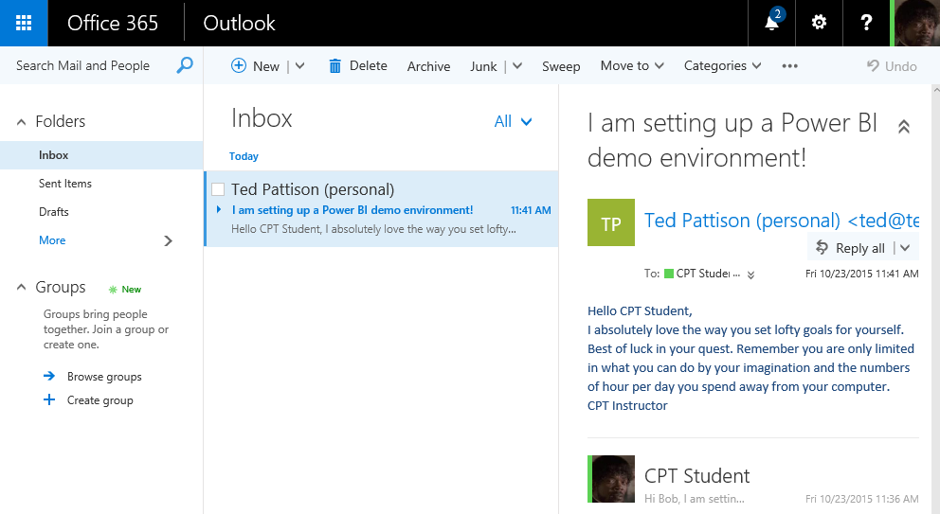

Having access to mail is valuable when you are working with Power BI. That's because the Office 365 and the Power BI service use email messages to send invitations and notification to users is response to user actions such as creating a new group workspace or sharing a dashboard.

### Exercise 4: Create an Azure Trial Account

In this exercise you will create a trial Azure subscription.

1. Navigate to **https://azure.microsoft.com/en-us/pricing/free-trial/**.
   1. Click the **Try it now** button to go to the sign up screen.

Note that you should still be logged in with the account created during the Office 365 trial creation, however, if you are not then make sure you log in using that account – this is critical to ensure that the Azure account is properly associated with your Office 365 tenant. Also, if you attempt to create more than one Azure trial account using the same personal information, credit card and/or verification number you may get an error as you are only allowed to create one trial account (Microsoft will not share what the specific combination of data is that constitutes a duplicate trial account).

* 1. On the sign up page provide the required information including the verification and credit card details. The credit card information is required but you will not be charged anything unless you explicitly choose to upgrade to a paid offering.
  2. Click **Sign up** to continue.
  3. Go through the entire process until the trial account has been created.

### Exercise 5: Verify PowerShell Connectivity

In this step you will use the previously installed PowerShell modules to verify connectivity and create a new Site Collection.

1. Use the **Windows** key to navigate to the Start screen and type **azure** to search for the Windows Azure Active Directory Module for Windows PowerShell.

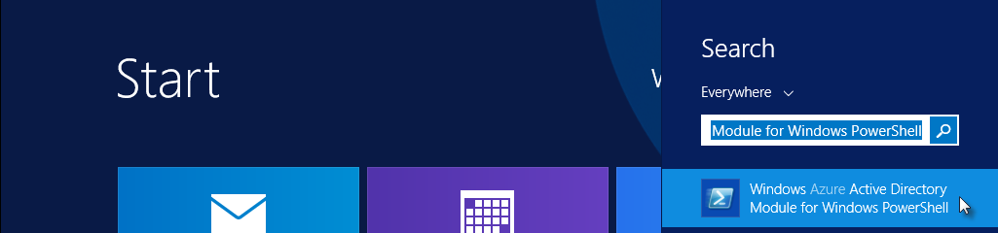

* 1. Click the **Windows Azure Active Directory Module for Windows PowerShell** application to open the PowerShell console window.
  2. Type the following command to store your credentials and establish a connection to the tenant (use the same username and password you used when creating the Office 365 trial - we’ll use these credentials later so keep the console window open when complete):

$cred = Get-Credential

Connect-MsolService -Credential $cred

* 1. Run the following command to retrieve your company information that you provided when creating the tenant

Get-MsolCompanyInformation

1. Now that you’ve verified your Azure Active Directory PowerShell module can connect to your tenant you can now validate that the SharePoint Online Management Shell module works.
   1. It’s not necessary to load the SharePoint Online Management Shell as the PowerShell module we need will be loaded automatically when you attempt to use one of the applicable cmdlets.
   2. Run the following command to connect to your SharePoint Online tenant:

Connect-SPOService -Url https://[your tenant]-admin.sharepoint.com -Credential $cred

* + 1. Be sure to replace **[your tenant]** with the value you provided when creating your Office 365 tenant (this will be the same value that is preceding **onmicrosoft.com** in your login).
  1. Run the following command to retrieve the list of existing Site Collections:

Get-SPOSite -Limit All | select Url

1. Create a new Site Collection using the **New-SPOSite** cmdlet.
   1. Be sure to replace **[your tenant]** with the value you provided when creating your Office 365 tenant:

New-SPOSite -Url https://[your tenant].sharepoint.com/sites/Test `

-Owner $cred.UserName `

-StorageQuota 1000 `

-Title "Test Site" `

-Template "EHS#1"

* 1. This command could take several minutes to complete.

1. Verify creation of the Site Collection.
   1. Navigate to **https://[your tenant]-admin.sharepoint.com**
   2. You should see your new Site Collection listed. Click the URL of the Site Collection to open its properties.
   3. Click the Web Site Address to open the Site Collection in a new window.

### Exercise 6: Create a New User

In this exercise, you will begin by making sure the PowerShell execution policy on the local machine allows you to run PowerShell scripts. After that, you will use the Windows PowerShell ISE to create a script to create new test user and assign a license to that user.

1. Use the **Windows** key to navigate to the Start screen and type **azure** to search for the Windows Azure Active Directory Module for Windows PowerShell.



* 1. Click the **Windows Azure Active Directory Module for Windows PowerShell** application to open the PowerShell console window.

1. Ensure that the current execution policy allows the execution of scripts by running the following command:

Set-ExecutionPolicy Bypass -Force -Scope CurrentUser

1. If not already created, create a new directory named **Scripts** on the **C:\** drive of the student VM.
   1. Once created, the path to this directory should be **C:\Scripts**
2. Use the **Windows** key to navigate to the Start screen and type **powershell ise** to search for the Windows PowerShell ISE.

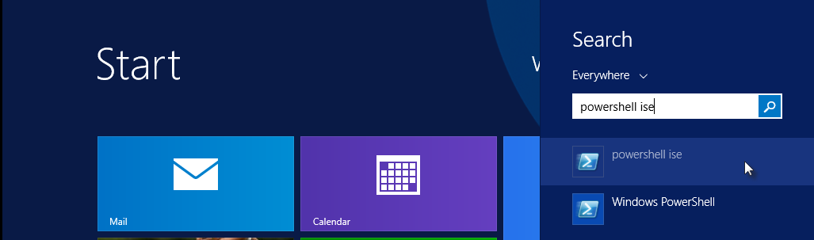

* 1. Click the **PowerShell** **ISE** application to open the PowerShell ISE window.

1. Click the **New** icon to create a new script file.

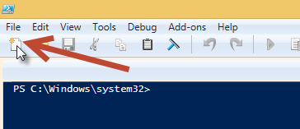

1. Enter the following script:
   1. Note the tick marks (`) to denote a new line when calling the various cmdlet.

function New-Student($username, $password, $displayName, $alternateEmail) {

# get tenant name from license prefix

$tenantName = (Get-MsolAccountSku)[0].AccountSkuId.split(":")[0]

# parse together license sku ID for Office 365 E5 license in current tenant

$licenseSku = $tenantName + ": ENTERPRISEPREMIUM"

# Create the user

New-MsolUser -UserPrincipalName $username `

-DisplayName $displayName `

-UsageLocation "US" `

-UserType Member `

-LicenseAssignment $licenseSku `

-AlternateEmailAddresses $alternateEmail `

-Password $password `

-PasswordNeverExpires $true

}

1. Click the **Save** icon to save the file as **C:\Scripts\New-Student.ps1**.

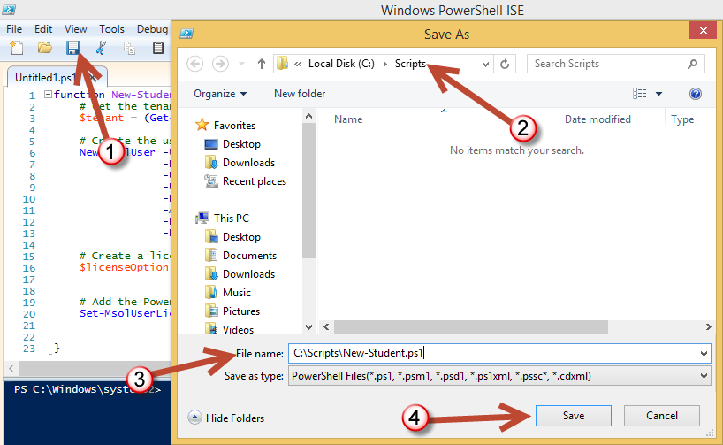

1. Click **Save** to save the file.
2. Add the following code to the bottom of the script file under the function you just created.

Connect-MsolService

New-Student -username "User1@[YOUR_TENANT_NAME].onmicrosoft.com" `

-password "pass@word1" `

-displayName "Bob White" `

-alternateEmail "bob@wingtip.com"

1. At this point, your script file should appear as the one below.

function New-Student($username, $password, $displayName, $alternateEmail) {

# get tenant name from license prefix

$tenantName = (Get-MsolAccountSku)[0].AccountSkuId.split(":")[0]

# parse together license sku ID for Office 365 E5 license in current tenant

$licenseSku = $tenantName + ":ENTERPRISEPREMIUM"

# Create the user

New-MsolUser -UserPrincipalName $username `

-DisplayName $displayName `

-UsageLocation "US" `

-UserType Member `

-LicenseAssignment $licenseSku `

-AlternateEmailAddresses $alternateEmail `

-Password $password `

-PasswordNeverExpires $true

}

Connect-MsolService

New-Student -username "User1@[YOUR_TENANT_NAME].onmicrosoft.com" `

-password "pass@word1" `

-displayName "Bob White" `

-alternateEmail "bob@wingtip.com"

1. Run the script by clicking the green arrow button on the toolbar of the Windows PowerShell ISE. The script should run and successfully create a new user in your office 365 tenancy.

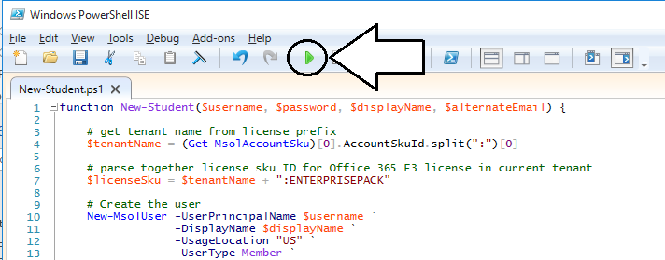

1. Verify account creation in the Office 365 admin center.
   1. Navigate to **https://portal.office.com/admin/default.aspx** and click **Active Users** within the **Users** node.
   2. Select the checkbox next to the new user and click **Edit** under the **Assigned license** section in the right panel.

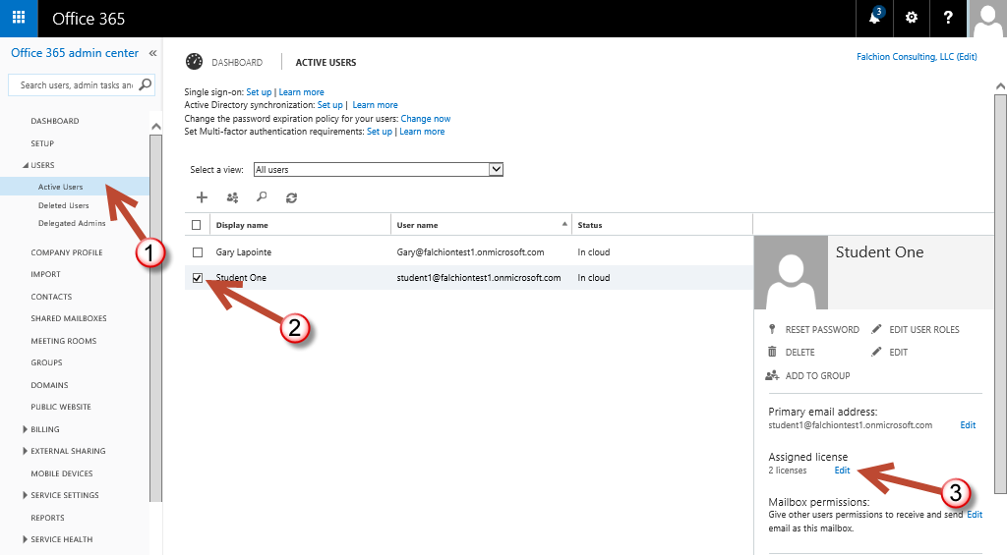

* 1. Verify the license assignment is as shown:

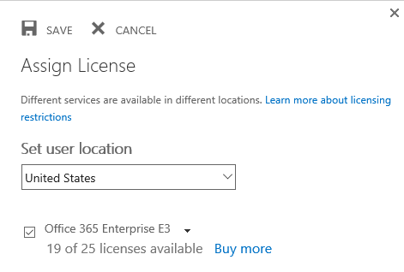

* 1. Click **Cancel** to close the Assign license dialog.

You have now finished this lab.